**Assignment-1**

**Q1. What do you mean by cells in an excel sheet?**

**Ans.** A cell is an int**ersection** between the row and the columns. In a simple language we can defined it a space where rows and columns meet.

Columns are identified by letters (A, B, C), while rows are identified by numbers (1, 2, 3).

Each cell has its own name—or cell address—based on its column and row.



**Q2. How can you restrict someone from copying a cell from your worksheet?**

**Ans**.We can restrict someone from copying a cell or range of cells from your Excel worksheet by protecting the worksheet and then applying specific protection settings. Here's how you can do it:

**Open your Excel Worksheet**:

Open the Excel file that contains the worksheet you want to protect.

**Select the Cells to be Protected:**

Click and drag to select the cells or range of cells that you want to restrict from being copied.

**Protect the Worksheet:**

To protect the worksheet, go to the "Review" tab in Excel (this might vary slightly depending on your Excel version) and click on the "Protect Sheet" or "Protect Workbook" option. You may be asked to set a password for protection. Make sure to remember this password because you'll need it to make changes to the protection settings later.

**Set Protection Options**

After entering the password, a dialog box will appear with various protection options. To prevent users from copying cells, you'll want to uncheck the "Select locked cells" option. This will prevent users from selecting the locked cells, including copying their contents.

**Apply Protection:**

Click the "OK" or "Protect" button to apply the protection. The selected cells are now protected from being copied.

**Save the Workbook:**

Don't forget to save your workbook to retain the protection settings.

**Q3. How to move or copy the worksheet into another workbook?**

The common way to copy a sheet to another workbook is this:

* Right click on the tab that you want to copy, and then click Move or Copy…
* In the Move or Copy dialog box, do the following:
  + Under To book, choose the target file. To place a copy into a new workbook, select (new book).
  + Under Before sheet, specify where to put the copy.
  + Select the Create a copy box.
  + Click OK.

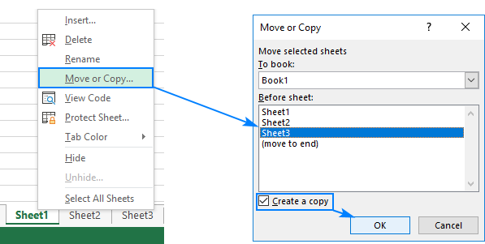

**Q4. Which key is used as a shortcut for opening a new window document?**

**Ans.** Ctrl + N

**Q5. What are the things that we can notice after opening the Excel interface?**

**Ans.** The interface components of Excel include the Quick Access Toolbar, Ribbon, Name Box, Formula Quick Menu, Formula Bar, Status Bar, Worksheet View Options, Zoom Slider Control, and the Zoom Percentage Indicator.

**Q6. When to use a relative cell reference in excel?**

**Ans.** Relative reference is a type of cell reference in Excel. This reference changes when the formula is copied to any other cell or any other worksheet. Relative cell references are used whenever calculations need to be repeated.

For instance, in cell A1, we have “=B1+C1.” On copying this formula to cell B2, the formula becomes “=C2+D2.” This is because the first formula refers to two cells on the right of cell A1 while the second formula refers to two cells on the right of cell B2. Cells B1 and C1 are to the right of cell A1 and cells C2 and D2 are to the right of cell B2.